Department of Computer Science and Information Technology

DRONACHARYA GROUP OF INSTITUTIONS
Greater Noida



Mini Project Report File On
Diabetes Prediction Using Machine Learning (2025 – 2026)
B.tech CSIT (3rd Yr 5thSem)

Submitted By-:
Team members-:
- Krishna Sharma (Roll no:2302300110059)
- Nikit Kumar (Roll no:2302300110070)
- Naman Phuloria (Roll no:2302300110067)
- Nitin Kumar (Roll no:2302300110071)
Submitted To-:
Prof. Shekhar Tyagi

Declaration

We hereby announce that the Mini Project Report titled
“DIABETES PREDICTION USING MACHINE LEARNING”
Presented by us as a partial completion of the criteria for the conferment
of the Bachelor of Technology degree in Computer Science & Information Technology.

This is a genuine piece of work done by us from the Dronacharya Group of Institutions in Greater Noida.
This project has not been presented by us for the attainment of any other degree or diploma.

Date: 15/11/2025 Location: Greater Noida

Krishna Sharma (Roll number: 2302300110059) Nikit Kumar (Roll no: 2302300110070)
Naman Phuloria (Roll no: 2302300110067) Nitin Kumar (Roll no: 2302300110071)

Certificate

This is to certify that the Mini Project Report titled
“DIABETES PREDICTION USING MACHINE LEARNING”
Submitted by -:
Krishna Sharma (Roll No: 2302300110059) Nikit Kumar (Roll No: 2302300110070) Naman Phuloria (Roll No: 2302300110067) Nitin Kumar (Roll No: 2302300110071)

As part of the requirements for the Bachelor of Technology degree in Computer Science & Information Technology from Dronacharya Group of Institutions, Greater Noida,
is an original and genuine work done under my guidance.

The content of this report has not been submitted to any other university or institution for the award of any degree or diploma.

Project Guide: Prof.Shekhar Tyagi

Acknowledgement

We are greatly in debted to our project guide Prof.Shekhar Tyagi For his able guidance throughout the course of this work.It has been an altogether difference experience to work with him and We would like to Thank him for his help , suggestions and numerious decisions. We gladly take this opportunity to thank Prof.Shekhar Tyagi for providing Facility during progress of project,also,for his kindly help,guidance and inspiration.
Last but not least we are also thankful to all those who help directly or indirectly to develop thus project and complete it successfully with Deep Reverence,
Submitted by -:
Krishna Sharma (Roll no:2302300110059) Nikit Kumar (Roll no: 2302300110070) NamanPhuloria (Roll no:2302300110067) Nitin Kumar (Roll no: 2302300110071)

Abstract

Diabetes is a long-term illness that can lead to a major problem in global healthcare. According to the International Diabetes Federation, around 382 million people world wide have diabetes, and this number is expected to double by 2035, reaching 592 million. Diabetes is a condition where the level of blood sugar in the body is too high. There are traditional ways to test for diabetes using physical and chemical methods. However, predicting diabetes early is a difficult task for doctors because diabetes affects many parts of the body, such as the kidneys, eyes, nerves, feet, and heart, and it is influenced by many different factors.

Data science can help other fields by providing new ways to solve common problems, like predicting medical conditions. Machine learning is a growing area within data science that focuses on how machines can learn from experience. The goal of this project is to create a system that can predict diabetes early with high accuracy by using results from different machine learning techniques.

This project uses three supervised machine learning methods: Support Vector Machine (SVM) to predict diabetes.

Table of Contents
- Introduction 8
  - Background
  - Problem Statement
  - Objective
  - Scope
  - Limitation

- System Requirement and Design 11
  - Hardware Requirements
  - Software Requirements
  - System Architecture
  - Flowchart
  - UML Diagram

- Implementation 15
  - Tools &Technologies Used
  - Proposed Methodology
- Model Evaluation 21
  - Model Selection and Training
  - Accuracy
  - Precision, Recall, F-1Score

- Prediction 23
- Result & Discussion 24
- Conclusion &Future Work 25-26
- Homepage, Diabetic or Non Diabetic Prediction 27-29
(Frontend Result)
- References(APA Style) 30
- Data Availability Statement 31

List of Figures & Tables
  - System Architecture diagram 12
  - Flow chart diagram of Machine Learning 13
  - UML Case diagram 14
  - Tool &Technologies Used Table 15
  - Diabetes Prediction Dataset Attributes Table 16
  - Diabetes Prediction dataset Table 18
  - Distribution of dataset for diabetes/Non-diabetes Patient 19
  - Data Pre-Processing 20
  - Accuracy 22
  - Precision,Recall,F-1ScoreTable 22
  - Prediction Output for diabetic/Non-diabetic Patient 23
  - Future Steps For Machine Learning Models 26
  - Homepage of Diabetes Prediction Model 27
  - Chances of Having Diabetes 28
  - Non Diabetes(You are Safe) 29

Chapter-1 Introduction

  - Background
Throughout the world, there are countless unending infections prevalent in evolving and developing nations. One such illness is diabetes.
Diabetes is a metabolic condition that either causes excessive amounts of insulin or insufficient levels of insulin in the human body.
Diabetes is perhaps the most deadly disease on Earth. It is not merely a disease, but also a precursor to various other conditions such as coronary failure, visual impairment, kidney disorders, nerve damage, and more. Therefore, the identification of such chronic metabolic disorders in their early stages can assist specialists globally in preventing the loss of human lives.

Currently, with the emergence of machine learning, AI, and neural systems, and their applications across various fields [1,2], we may have the opportunity to find a solution to this issue.
ML methods and neural systems help scientists uncover new insights from existing health- related data, which can be beneficial for both disease monitoring and detection.
The current work is conducted using the Pima Indians Diabetes Database.
The aim of this framework is to develop an ML model that can accurately predict the likelihood of a patient having diabetes. The typical diagnostic process for diabetes involves the patient visiting a symptomatic center. One of the main challenges in bioinformatics is achieving accurate results from the information. Human errors or various laboratory tests can complicate the identification process of the disease.

This model can predict whether a patient has diabetes or not, helping specialists ensure that patients requiring clinical attention receive it on time, and also helping to prevent the loss of human lives.

Cause of Diabetes
Genetic elements are the primary reason for diabetes. It results from a minimum of two mutated genes on chromosome 6, which is responsible for the body’s response to different antigens. Viral infections may also impact the development of type 1 and type 2 diabetes. Research indicates that infections from viruses like rubella, Coxsackie virus, mumps, hepatitis B virus, and cytomegalovirus raise the likelihood of developing diabetes.

Forms of Diabetes:

Type1
Type 1 diabetes indicates that the immune system is weakened and the cells do not generate insulin in adequate quantities. There are no comprehensive studies that confirm the causes of type 1 diabetes, and there are no established prevention methods at this time.

Type2
Type-2 diabetes indicates that the body produces insufficient insulin or cannot utilize it properly. This is the most prevalent form of diabetes, impacting 90% of individuals diagnosed.

It results from both hereditary influences and lifestyle choices.

In recent years, data mining and machine learning have progressed, providing dependable supporting tools in the medical field. The technique of data mining is utilized to pre-process and identify the significant features from healthcare data, while the machine learning approach aids in automating diabetes prediction [14].
Data mining and machine learning techniques assist in uncovering concealed data patterns through advanced methods, allowing for reliable decision-making based on accuracy. Data mining involves a process that incorporates multiple techniques, Incorporating machine learning, statistics, and database systems to uncover a trend from the large volume of data [15].

Problem Statement
The increasing prevalence of diabetes necessitates the development of efficient prediction models. Current methods lack real – time accessibility and often fail to identify individuals at risk early enough for preventive measures. This project aims to develop a machine learning based system that can predict the likelihood of diabetes in individuals based on various health parameter

Objective
    - To collect and process a dataset containing relevant health features.
    - The implement and compare multiple machine learning algorithm for diabetes prediction.
    - To evaluate the performance of the mode using appropriate metrics.
    - To develop a user friendly interface for real-time predictions.

Scope
The project will focus on prediction Type – 2 Diabetes using a dataset that includes feature such as age , BMI , glucose levels , blood pressure and insulin levels.The scope is limited to the use of supervised learning algorithms and does not extend to deep learning technique or real- time sensor data integration.

Limitation

    - Our data set are have around 768 data of women’s not for men.
    - Model Accuracy by using svm is 78 %.
    - Moderate Accuracy because of the dataset quantity.
    - Quality of data is Moderate (Most of the data containing Insulin level =0).
    - Voice / interface accuracy : If voice input issuse, recognition Errors may occur with ascent or noise.

Chapter-2
System Requirement & Design

  - Hardware Requirements-:
    - System : Pentium Dual Core.
    - Hard Disk :120 GB.
    - Monitor : 15” LED
    - Input Devices : Keyboard, Mouse
    - Ram: 6 to 8 GB (enough)

Software Requirements-:
    - Operating System :Window 7/10
    - Coding Language :Python
    - Tool : Python 3.6 upto 3.13

System Architecture-:
The system architecture of the Diabetes Prediction Model is designed to predict whether a person is diabetic or not based on specific medical attribute such as glucose level, BMI, Insulin level, age etc.

It consist of the following components-:

Data Collection Layer-:
  - The dataset (eg,Pima Indian Diabetes Dataset) is collected from a reliable source like kaggle.
  - It contains features such as Pregnancies,Glucose, Blood Pressure , Skin , Thickness , Insulin , BMI , Diabetes Pedigree Function and Age.

Data Pre-processing Layer-:
  - Handles missing values , normalization / scaling, and feature selection.
  - Ensures clean and standardized input for the model.

Model Training Layer-:
  - Machine Learning Algorithm (eg Logistic Regression , random Forest, XGBoost) are trained using training data.
  - The dataset is split in to training and testing sets to evaluate performance.

Prediction Layer-:
  - The trained model predicate the outcome (Diabetic/Non– Diabetic) based on new input data.

Evaluation Layer-:
- Model performance is metrics such as Accuracy , Precision , Recall and F1-Score.
- A confusion matrix used to visualize results.

User Interface Layer (optional)-:
  - A simple web approve Python–Based interface allows user to input their medical data and get predictions.

[User Input]

[Data Pre-processing]

[Machine Learning Model]

[Prediction Output] [Result Display: (Diabetic / Non-Diabetic)]

  - Fig - System Architecture Diagram

Flowchart-:
The flowchart represents the working of the diabetes prediction system. The process begins with data collection, followed by preprocessing to remove missing values and normalize the data. The dataset is then split into training and testing sets The machine Learning model is trained and evaluate using performance metrics. Finally , the trained model predicts whether a person is diabetic or not based on input medical data.
Diabetic Result (Diabetic/Non-Diabetic)
End
Evaluate Model (Accuracy,Precision etc)
Make Prediction (Input new user data)
Split Data (Train/Test)
Train ML Model (Logirithmic Regression)
Data Preprocessing (Handle missing values, Scaling , cleaning)
Start
Collect Dataset
  - Fig–Flowchart diagram of Machine Learning

UML DIAGRAMS-:
UML represents Unified Modeling Language. UML is a standardized general-purpose modeling language used in object-oriented
software engineering. The Object Management Group manages and developed the standard. The aim is for UML to serve as a universal language for modeling objectoriented computer software. Presently, UML consists of components: notation and. In the future, a variant of me to process might also
be integrated or associated with UML. The Unified Modeling Language serves as a standard language for specifying, visualizing, constructing, and documenting the core aspects of software systems.
Swell as for business modeling and various non-software systems

Diabetes Prediction System
User

- Upload / Input Data
- Train ML models (LR , RF , XGB , SVM , KNN)
- Evaluate Accuracy
- Predict Diabetes Status
  - Fig – UML Case Diagram

Chapter- 3 Implementation

  - Tools & Technology Used
The development of the diabetes Prediction System was carried out using various tools, technologies, and libraries that enabled efficient data processing, model training and evaluation.

Category | Tool / Technology | Description / Purpose
Programming Language | Python | Primary language used for machine learning, data processing, and model  implementation.
Development Enviorment | Google Colab / Jupyter Notebook / VS Code | Used for writing,executing,  testing Python code interactively.
Libraries Used | NumPy , Pandas,  Streamlit | For data visualization ,plotting graphs and Frontend Graphical  User Interface.
 | Sckit-learn (sklearn) | Core machine learning usedfor mode building ,training and evaluation (Logistic Regression  , Random Forest , KNN  ,SVMetc)
 | SVM  Support Vector Machine | Algorithm used for high  performance and Prediction
Dataset | PIMA Indian Diabetes Dataset (Kaggle) | Standard dataset containing  medical records of women for diabetes prediction.
Operating System | Window / Linux | Compatible OS platform  For python development.

1.4 Fig -Tool &Technologies Used

Proposed Methodology
This research intends to present a model for classifying diabetes. A variety of algorithms
and various methods have been utilized, including conventional machine learning algorithms, ensemble learning techniques, and association rule learning to attain
optimal classification accuracy.
This study commenced with the development ofthe research problem, which includes a literature review and the formulation of the research issue. Following the definition
of the research problem, this study delineated the research scope, objectives, and constraints of the research methodology.
The dataset collection is the second phase of the research. The items in the
dataset were gathered from the National Institute of Diabetes and Digestive and Kidney Diseases. The third stage of the study involved preparing the data, which encompassed: Transforming Data into Suitable Format-:
- Data Preparation
- Employ Machine Learning for manipulation
- During the experimentation phase, numerous tests were carried out, and data was gathered
DATASET
The dataset was acquired from the National Institute of Diabetes and Digestive and Kidney Diseases. The diabetes dataset consists of a total of 9 attributes. The dataset includes 768 entries of female patients. The diabetes dataset consists of total of 9 attributes. Every individual in the records is female, and the count of pregnancies they have experienced is noted as the dataset's initial attribute. The second value is the glucose level, followed by blood pressure (mm Hg), the fourth is the triceps skin fold thickness (mm), then comes the 2-hour serum insulin (mu U/ml), sixth is the body mass index (weight in kg/ (height in m)
^2), then seventh the diabetes pedigree function, and the second to last value is age(years)

Sr. Number | Attributes
I | Pregnancy
II | Glucose Level
III | Blood Pressure
IV | Skin Thickness
V | Insulin Level
VI | BMI (Body Mass Index)
VII | Diabetes Pedigree Function
VIII | Age
  - Fig–Diabetes Prediction Dataset Attribute

- Pregnancies:
Individuals who experience gestational diabetes face an increased risk of developing type 2 diabetes in the future.
Subjects with a greater number of pregnancies have an elevated risk of diabetes onset.

- Glucose:
The participants underwent an oral glucose tolerance test, during which they received glucose, and their plasma glucose levels were measured after 2 hours.
Individuals exhibiting elevated glucose levels after 2 hours face an increased risk of developing diabetes.

- Blood Pressure:
A blood pressure exceeding 140/90 mm Hg is associated with a higher likelihood
of developing diabetes. Certain individuals with a diastolic blood pressure of 70 mmHg may develop diabetes.

- Skin Thickness:
Skin thickness is mainly influenced by collagen levels and is heightened in individuals with insulin-dependent diabetes.

- Insulin :
Normal insulin levels after 2 hours of glucose administration is16-166ml U/L. Subjects having lower or higher levels than said value are at a higher risk.

- Body Mass Index (BMI) :
Subjects having a BMI over 25 have a relatively Sr. Number Attributes I Pregnancy Attribute II Glucose Attribute III Blood Pressure Attribute IV Skin thickness Attribute V Insulin Attribute VI Body Mask Index VII Diabetes Pedigree Function Attribute VIII Age Criteria Diabetes Prediction Using Machine Learning Dept of CSE, SSGMCE, Shegaon (Session: 2022- 23) 13 high risk in having diabetes.

- Diabetes Pedigree Function :
The diabetes pedigree function provides “a synthesis of the diabetes mellitus history in relatives and the genetic relationship of those relatives to the subject.” The higher the DPF, the more likely it is for a subject to be diabetic.

- Age:
Diabetes is prevalent in any age group, but is commonly foundin middle aged adults (45 onwards). Taking that into consideration, subjects with in the higher age group have a higher expectancy of diabetes.

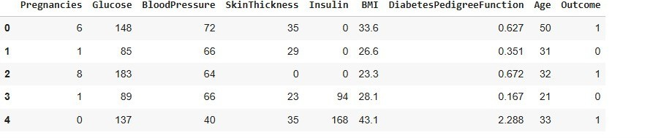

  - Fig– Diabetes Prediction Dataset.

Distribution of Diabetic Patient -: In our attempt to develop a Diabetes prediction we encountered a slightly disturb
dataset. Out of the total 768 samples, around 500 were Designated as 0, denoting the non existence of diabetes., while 268 were designated as 1, denoting the existence of diabetes.

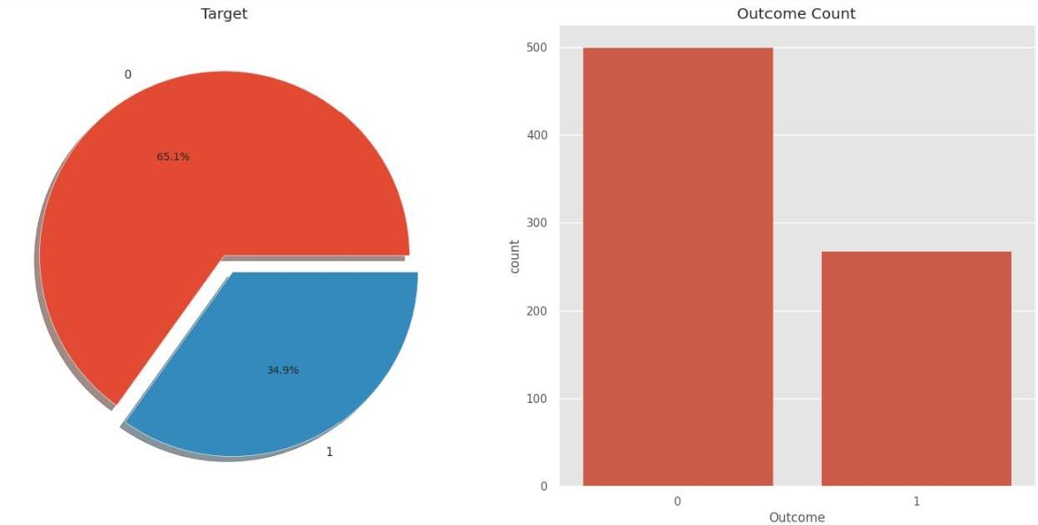

  - Fig–Distribution of dataset for Diabetic / Non–Diabetic Patient

DATA PRE-PROCESSING
Data preprocessing is a process in which that is actual use for converting the basic data in to the clean dataset. It is the step in which the data convert or an encode to the state that the machine can be easily recognize.
The major task of data pre-processing in learning process is to remove the unwanted data and filling the missed value. So that it help to machine can be trained easily.

Data Integration
Data Cleaning
Data Transformation
Data
Pre-Processing
Data Reduction or Dimension Reduction

  - Fig– Data Pre-Processing

Chapter -4

Model Evaluation

  - Model Selection & Training

    - Logistic Regression-:
Logistic regression is a machine learning used when dependent variables are able to categorize, The outputs obtained by using the logistic regression is based on the available features. Here sigmoidal function is used to categorize the output.

K-Nearest Neighbors-:
K-Nearest Neighbors (KNN) algorithm uses ‘Feature similarity’ to predict the values of new data points which further means that the new data point in the training set.

SVM (Support Vector Machine)-:
SVM is supervised learning algorithm used for classification .In SVM we have to identify the right hyper plane to classify the data correctly .In this we have to set correct parameters values. To find the right hyperplane we have to find right margin for this we have choose the gamma value as 0.0001 and rbf kernel . If we select the hyperplane with low margin leads to miss classification.

Random Forest-:
This algorithm consist of trees and the number of tree structures present in the data is used to predict the accuracy. Where leaves are corresponds to the class labels and attribute are corresponds to on ternal node of the tree . Here number of trees in forest used is 100 in number and Gini index is used for splitting the nodes.

    - XGBoost-:
XGBoost (extreme Gradient Boosting) is one of the most powerful and widely used machine learning algorithms – especially for classification and regression problems like your diabetes Prediction. It is an optimized implementation of the Gradient Boosting algorithm, It builds ensemble of decision trees, where each new tree corrects the errors made by the previous ones.

4.2.Accuracy Score-:

Machine Learning Algorithm | Result
SVM | 78.0
Random Forest | 78.4
XGBoost | 79.0
KNN | 76.6
Decision Tree | 75.0

  - Fig–Accuracy Table

4.3.Precision , Recall , F-1 Score-:

Metrics | Your Value
Precision | 66.0
Recall | 75.68
F-1Score | 61.54
  - Fig– Precision, Recall, F-1 Score Table

Chapter– 5

Prediction
- The trained model predicts the outcome 1=Diabetic,
- 0 = Non- Diabetic based on user input values.
- Prediction are displayed through the interface or console Output
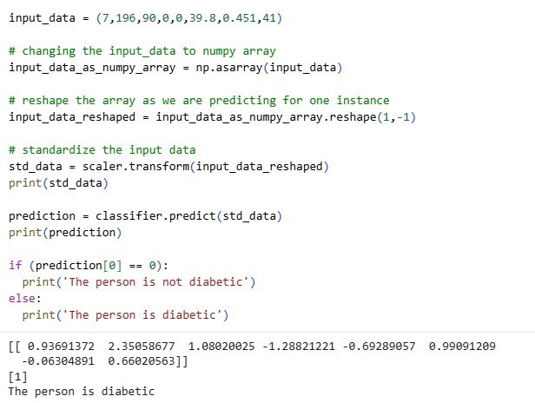

  - Fig– Prediction for Diabetic / Non-Diabetic

Chapter- 6

Results & Discussion
The table below displays the performance values of various classification algorithms, calculated using different measures. Based on the table, it is observed that Logistic regression exhibits the highest accuracy.Therefore, the Logistic regression machine learning classifier is capable of predicting the likelihood of diabetes with greater precision than other classifiers.

Accuracy Score-:

Machine Learning Algorithm | Result
SVM | 78.0
Random Forest | 78.5
XGBoost | 79.0
KNN | 76.0
Decision Tree | 75.0
1.9 Fig– Accuracy Table
So with the help of above mentioned procedure, we have completed our project named as Diabetes Predication System using Machine Learning to improve diabetes detection process using machine learning. In this project, the data was formulated in different formulations and the model (SVM ) was trained with above 78 % accuracy.

Chapter–7

CONCLUSION

The proposed project on Diabetes Prediction using Machine Learning Demonstrates the potential of data-driven models in assisting healthcares system to identify individuals at risk of diabetes at a an early stage.By analyzing medical parameters.

Such as Pregnancies , Glucose Level , Blood Pressure , Skin Thickness
, BMI , Diabetes Pedigree Function , Age.Machine Learning algorithms can provide reliable predictions that supporttimely diagnosis and intervention.

The Project Highlights the advantages of integrating computational intelligence into the medical domain, offering accuracy , efficiency and scalability compared to conventional methods. Although the system does not replace professional medical judgement, it can serve as an effective decision-support tool for healthcare providers.

Overall the project emphasizes that predictive analytics in healthcare can reduce the disease burden ,improve patient outcomes, and guide preventive strategies. Future improvements may include expanding the datsset , integrating the model into real healthcare applications for wide accessibility.

      - The Project aims to develop a machine learning – based system for predicting diabetes, addressing the need for early detection and intervention.

      - The proposed approach uses various classification and ensemble learning method in which SVM classification used and achieved 78.0 % accuracy has been achieved.

FUTURE SCOPE

In future, we will try to create a diabetes dataset in collaboration with a hospital or a medical institute and will try to achieve better results. We will be incorporating more Machine Learning and Deep learning models for achieving better results as well .

For later work It is far vital to conduct in hospitals actual and newest sufferers Information for regular instructing and development of our present model.
The amount of the data item has massive sufficient for education and forecasting. Some further methods and portraits need to take a look of DM (data mining).
To expand a chain of regulation and quality approach to stop human beings from come out of data mining.
It assists to minor the increase price of blood glucose and subsequently reduce the danger of forecasting data mining.
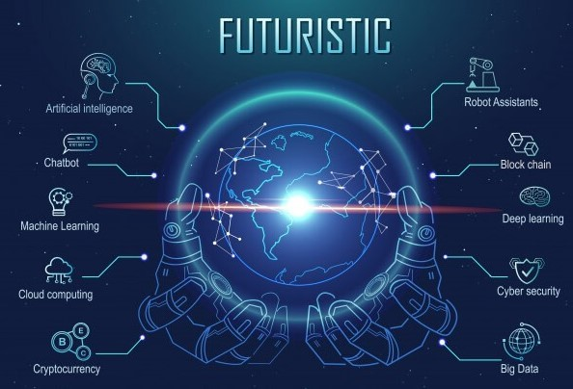
  - Fig–Future Steps for Machine Learning Models

Chatpter-8 Result of Prediction

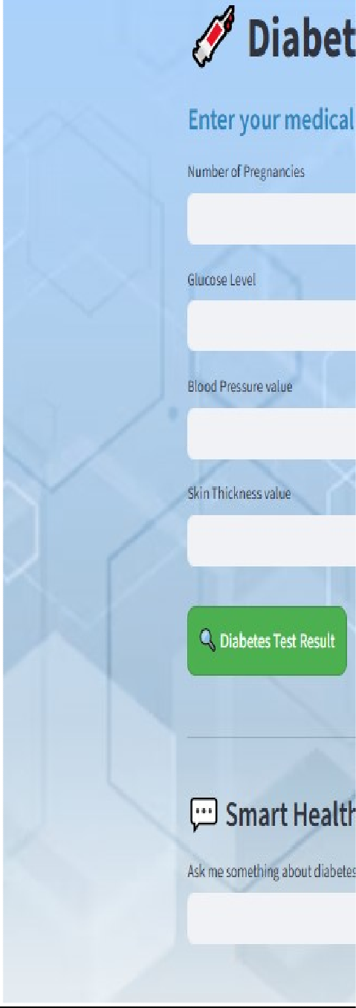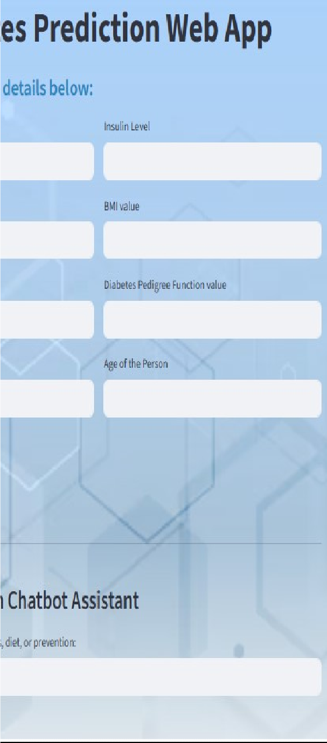

  - Fig- Homepage of Diabetes Prediction Model

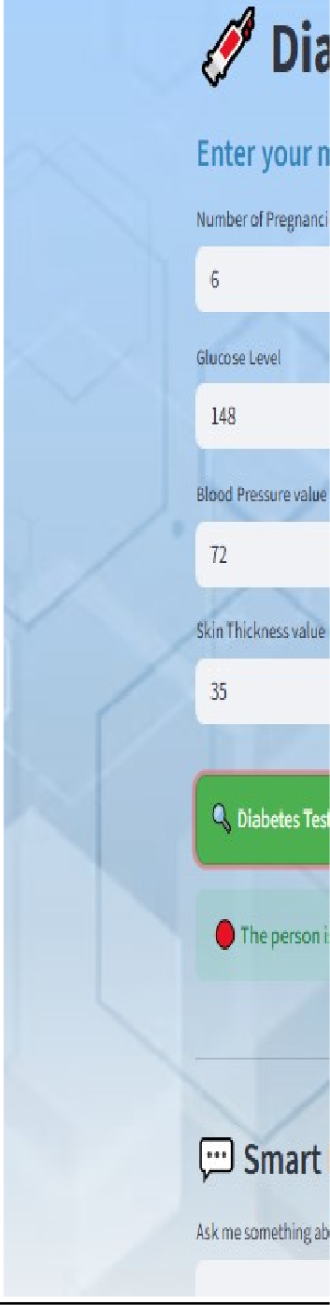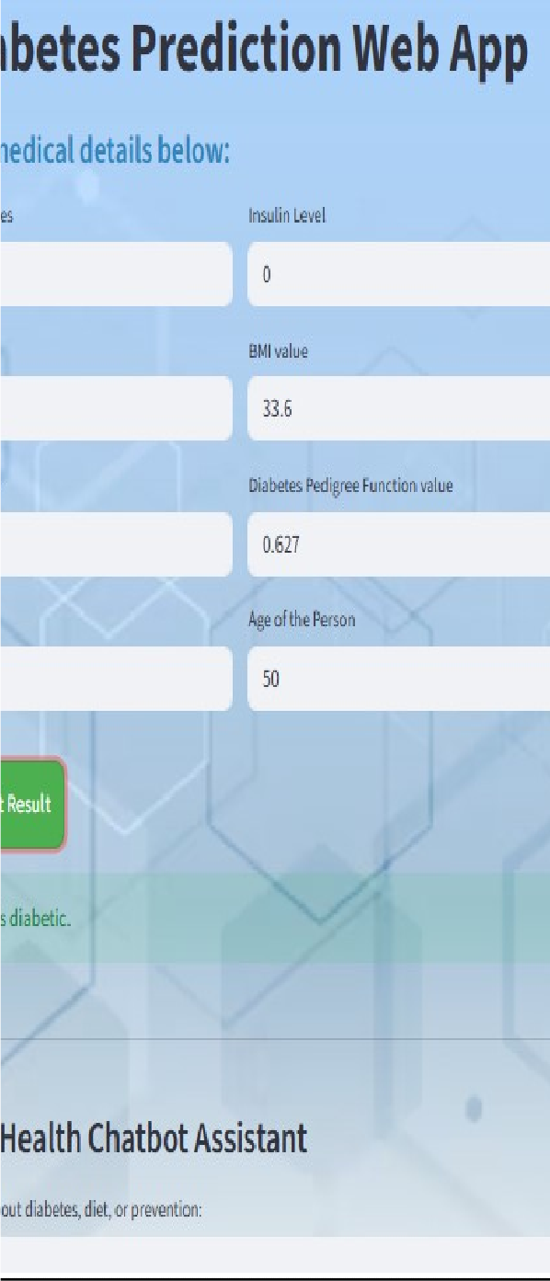

  - Fig– Result of Prediction (Diabetic)

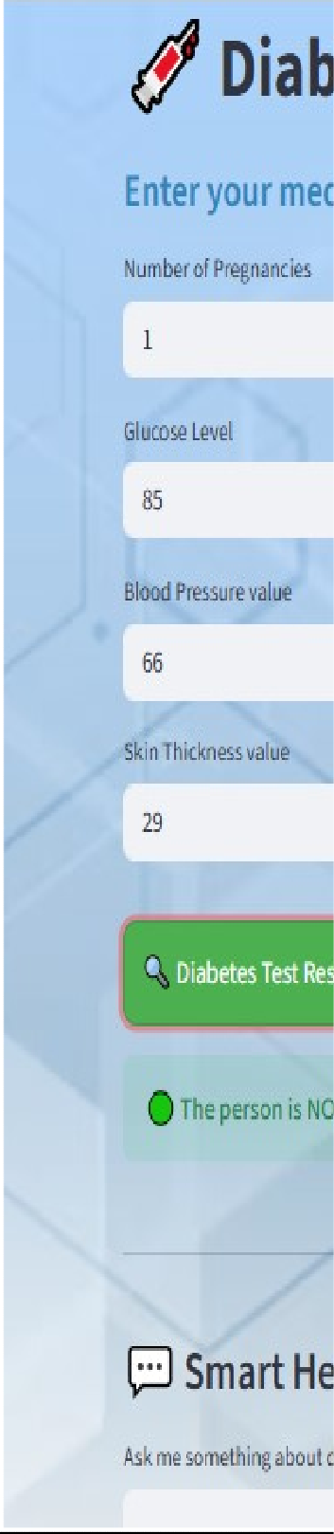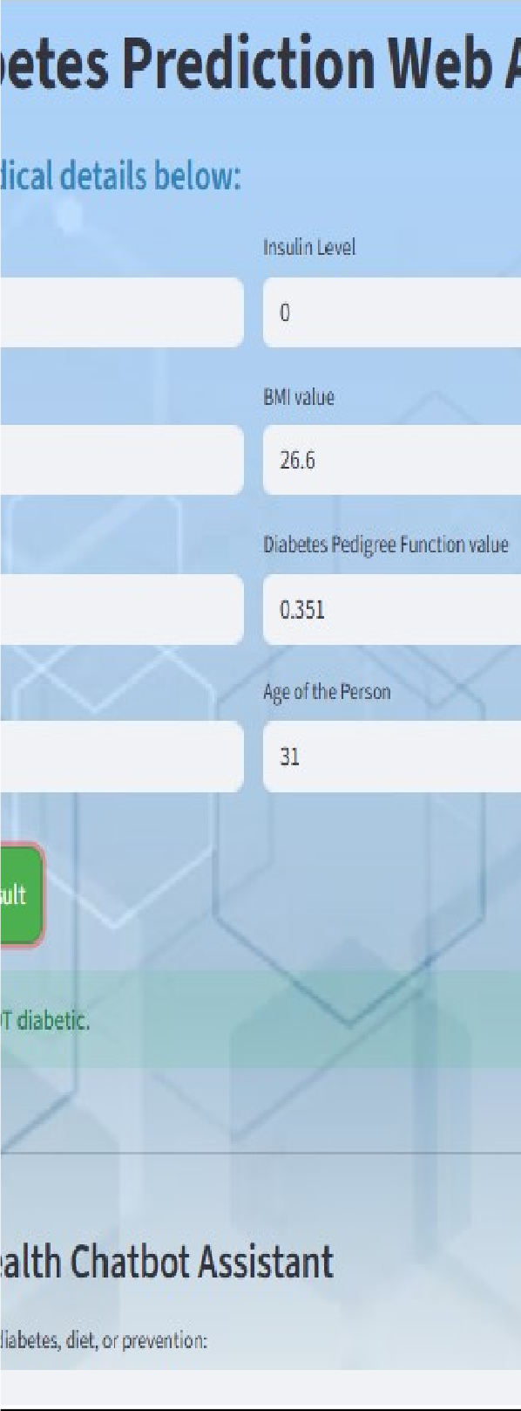

  - Fig– Result of Prediction (Non–Diabetic)

Chapter-9

References (In APA Style)
    - Dua,D.,&Graff,C.(2019).UCI Machine Learning Repository : Pima Indians Diabetes Database. University of Retrieved from https://archive.ics.uci.edu/ml/datasets/diabetes
    - Kumar, V., & Singh, D. (2020). Diabetes prediction using machine learning algorithms.International Journal of Computer Applications, 176(30), 26–29. https://doi.org/10.5120/ijca2020919978
    - Patel,J.,& Gupta,K.(2021).A comparative study of machine learning techniques for diabetes prediction. International Journal of Advanced Research in Computer Science, 12(3), 45–50. https://doi.org/10.26483/ijarcs.v12i3.6748

    - Choubey,D.,Paul,S.,& Yadav,S.(2022).Predictive analysis for diabetes using machine learning techniques. International Journal of Engineering Research & Technology (IJERT), 11(4), 1–6. https://doi.org/10.17577/IJERTV11IS040015

    - Pedregosa,F.,Varoquaux,G.,Gramfort,A.,Michel,V.,Thirion,B.,Grisel, O., ... & Duchesnay, E. (2011). Scikit-learn: Machine learning in Python. Journal of Machine Learning Research, 12, 2825–2830. Retrieved from https://scikit-learn.org/
    - Chen,T.,& Guestrin,C.(2016).XGBoost : A scalable tree boosting system. Proceedings of the 22 nd ACM SIGKDD International Conference on Knowledge Discovery and Data Mining, 785–794. https://doi.org/10.1145/2939672.2939785
    - McKinney,W.(2010).Data structures for statistical computing in Python. Proceedings of the 9th Python in Science Conference, 51–56. https://doi.org/10.25080/Majora-92bf1922-00a
    - Hunter,J.D.(2007). Matplotlib : A 2D graphics environment. Computing in Science & Engineering, 9(3), 90–95. https://doi.org/10.1109/MCSE.2007.55

Data Availability Statement

The private dataset of female Indian patients and programming codes are available at the following link : GitHub

